益阳市一中2014年下学期高一入学考试
英语试题
时量：90分钟 总分：150分
听力技能 (共两节，计25分)
第一节 听力选择 ( 15小题，计15分)
根据你听到的对话，选择正确的答案回答问题。
听下面5段对话，每听完一段对话后，做1个小题。
- What will the man eat?
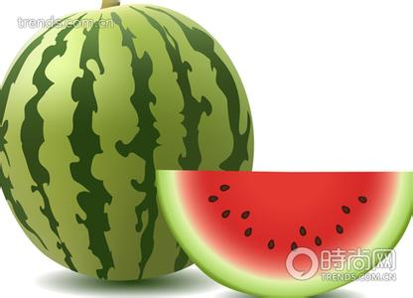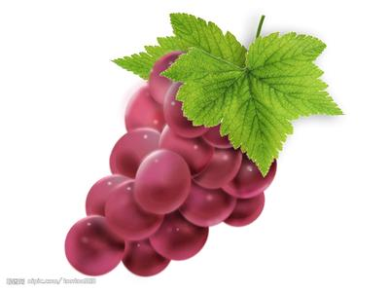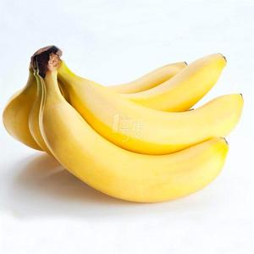
A. B. C.
2.Which animal does the man like best in the zoo?

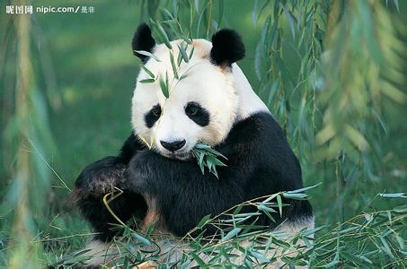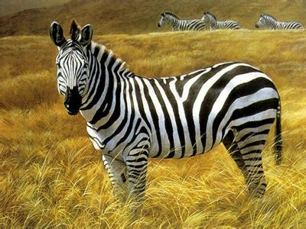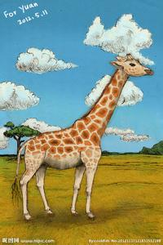
A. B. C.
- What does the woman look like now?
A. She has short hair. B. She has long hair. C. She has curly hair.
4. Whose book is it?
A. Mary’s B. Henry’s C. Jenny’s
5. What clothes may the man wear?
A. A T-shirt B. A shirt C. A coat

听第六段对话，做第6-7小题。
6. Where is Ann going?
A. To the park. B. To the library. C. To the supermarket.
7. What would Sam like?
A. Oranges B. Bananas C. Apples
听第七段对话，做第8-9小题。
8. What is Rosa doing now?
A. She is watching TV. B. She is doing her homework. C. She is reading a storybook
9. What does Ted borrow from Rosa?
A. A DVD player and some CDs.
B.A TV set and some CDs.
C. Today’s newspaper.

听第八段对话，做第10-12小题。
10. Did Linda use to be afraid of the dark?
A. It isn’t mentioned. B. No, she didn’t. C. Yes, she did.
11. Is Linda afraid of the dark now?
A. Yes, she is. B. It isn’t sure. C. No, she isn’t.
12. What does the boy do about the dark when he goes to sleep?
A. He always goes to bed with his mother.
B. He always goes to bed with the bedroom light on.
C. He always goes to bed with wonderful music.

听第九段对话，做13-15小题。
13. What are they talking about?
A. Their classmates. B. Their subjects C. Plans for the new term.
14. How did Jim do last term?
A. He did well. B. He failed the English exam. C. He did well in no subject.
15. What does Tom plan to do?
A. Get his English better. B. Get his math better. C. Get his Chinese better.
- 笔录要点（5小题，计10分）
根据你所听到的内容，填写下面的表格，每空不超过3个单词。
News Information Card
News 1 | On July 12, in Spain, a 16 appeared in a park. At last it was returned to the zoo  by the 17 . In the accident, 18 was hurt.
News 2 | British people sent 19 billion text messages last month. That means  more than 20 million messages each day.

第二部分 知识运用（共两节 计50分）
第一节 语法填空 ( 15小题，计30分)
从A、B、C三个选项中选择正确的答案填空。
21. She lost her book and borrowed from the nearby library.
A. another B. it C. one
22. Listen! Do you hear someone for help?
A. calling B. call C. to call
23. Close the door of fear behind you, and you the door of faith open before you.
A. saw B. have seen C. will see
24. –John, what in your hand ?
-- Look, It’s a birthday gift for my grandma.
A. had you held B. are you holding C. do you hold
25. I want to know ?
A. where she lives B. where does she live C. where is she living
26. Time, correctly, is money in the bank.
A. to use B. used C. using
27. You buy a gift, but you can if you want to.
A. must B. don’t have to C. have to
28. How beautiful she sings! I have never heard voice.
A. better B. the better C. a better
29. When asked they needed most, the kids said they wanted to feel important and loved.
A. what B. why C. whom
30. You and I could hardly work together, ?
A. could you B. couldn’t I C. could we
31. ——May I surf the Internet now?
——No, ______ you have finished doing the dishes.
A unless B if C because
32. ——Do you know ______ the MP4 yesterday?
——Sorry, I've no idea about it.
A how much did he pay for B how much he paid for
C he paid for how much
33. Is that the man ______ helped us a lot after the earthquake?
A whose B which C who
34. ——You have seen the film The Dead Reading, haven’t you?
——______. How I wish to see it again!
A No, what a pity B No, I haven’t C Yes, I like it
35. ——How did you find your visit to Beijing, Mary?
——______.
A Oh, wonderful indeed B I went there alone
C First by train and then by ship
第二节 词语填空 ( 10小题，计20分)
通读下面的短文, 掌握其大意, 然后从各题所给的A、B、C三个选项中选出一
个最佳答案。
“Remember, your father is only one year older than you.” That was Mom’s usual excuse when dad said the wrong thing or did something foolish.
Dad 36 drinking exactly one year before I was born. He 37 a group of other people who had also stopped drinking. I loved my dad but I hated the way his weekly meeting took him away form me. It seemed they were more 38 to him than I was. But with my birthday 39 I thought dad would make an expectation(破例). “Can’t you 40 it just this once? Saturday is my birthday!” I begged him. He 41 , “I’m chairing the meeting on Saturday. We’ll have your party on Sunday.”
Saturday evening I sat on my bed, feeling sorry for myself. Dad started to leave, paused and said, “Why not come with me tonight? It’s an opening meeting. 42 are welcome.” What would I do at their meeting? But maybe I needed to see why something dad did every week mattered so much.
After we arrived, dad announced the theme of the meeting was going to be gratitude(感恩). “Today I’m 43 seventeen years of stopping drinking,” he continued. “One year after quitting drinking I received the most 44 gift of my life, my daughter. I’m so grateful that she has never seen me drunk.” Shame washed over me.
Later , a man called Dave also told us his 45 . Only then did I know it was dad that saved his life from drinking. Dad was the reason he was at the meeting that day. Showing up week after week and meeting with people, dad was changing lives. I was so proud of him.
36. A. quitted B. enjoyed C. considered
37. A. encouraged B. joined C. respected
38. A. challenging B. important C. successful
39. A. ending up B. growing up C. coming up
40. A. miss B. replace C. exchange
41. A. said B. refused C. continued
42. A. none B. both C. All
43. A. facing B. performing C. celebrating
44. A. expensive B. precious C. generous
45. A. story B. question C. answer

第三部分 阅读技能（共三节，计40分）
第一节 阅读选择 ( 10小题，计20分)
阅读下面的短文，从每题所给的A、B、C三个选项中，选出最佳选项回答问
题或完成句子。

A
Generally people hate mice but one mouse has won the hearts of the people all over the world—the famous Mickey Mouse.
About 50 years ago films were silent. A man named Walt Disney made a cartoon mouse that could talk in the films. He named his mouse Mickey Mouse. People were very excited by the talking mouse.
Before long, Mickey became great success with both young and old people. Children loved to see their lovely friend because he brought joy and laughter to them.
Mickey was a clean mouse right from the beginning. Perhaps this is one reason why people hate real mice but love Mickey Mouse. In his early life, Mickey made some mistakes. People were very angry. They wrote to Disney that they didn’t want Mickey to do silly things. As there were some things that Mickey couldn’t do, Disney created a new animal named Donald Duck. He also created a dog called Pluto. The dog does stupid things and makes mistakes wherever he goes. Now our Mickey Mouse is not only clean, but more important. He appears as a star of beauty and wisdom（智慧. He had friends in almost every country.
46. Children loved their Mickey Mouse because .
A. he could speak English B. he brought them joys and laughters
C. he wasn’t a real mouse
47. Generally people all over the world hate mice except .
A. Mickey Mouse B. Pluto C. Donald Duck
48. Disney created a new animal named Donald Duck because .
A. except Donald Duck, Mickey could do some things
B. Mickey could do all the things with Donald Duck
C. there were some things that Mickey could not do
49. Mickey is a and important mouse today.
A. stupid B. dirty C. clean
50. Today Mickey Mouse has friends .
A. in the U.S B. almost all over the world
C. in China

B
I heard the bees long before I saw them.
It was a very hot afternoon, and we decided to cool off in the river near my home. As we climbed down a small rocky hill toward the water, my boyfriend John suddenly started to shout then jumped into the water below. Peter and Mary quickly followed but I was too far away to jump. I was trapped.
I heard a low hum(嗡嗡声)，which was growing louder. From a distance, the group of bees looked almost like a cloud of smoke. As it got closer, I realized it was actually thousands of bees flying towards me.
All I could do was cover my face with hands. Crazily, I thought that if I sat very still, the bees would think I was just another rock.
After a few minutes, I knew my plan hadn’t worked. The bees were attacking me. I could hear my friends shouting at me to get down to the pool fast.
But it wasn’t so easy. I was in great pain and the only way I could get away was to use my hands to climb down the rocks. However, I was afraid to do that at first because my face would be unprotected. The noise the bees made was so loud and frightening, but I had no choice.
I rushed down the rocks and jumped into the pool, but I don’t remember doing it. I was just so happy to be free from the pain. I was safe, and the water felt wonderful.
But we still weren’t out of danger. Every time we tried to climb out of the pool, the bees flew back over our heads. We spent the next three hours in the water, putting our heads under the water from time to time to avoid the bees until they finally lost interest.
51. How many people went swimming that day?
A. Two. B. Three C. Four

52. The underlined word “it” (in Paragraph 3) refers to .
A. a rock B. the group of bees C. a hill
53. At first why didn’t the writer want to climb down the rocks?
A. She was afraid she would fall.
B. She was too far away from pool.
C. She thought the bees would follow her.
54. How did the writer escape the bees?
A. She covered her face with her hands.
B. She hid behind the rocks.
C. She jumped into a water pool.
.55. In what order are the following mentioned in the story?
a. The writer rushed down the rocks.
b. John jumped into the water.
c. The low hum grew louder.
d. The bees flew back over their heads.
e. The bees were attacking the writer.
A. b c e a d B. b a e c d C. c d e a b

第二节 摘录要点 ( 5小题， 计10分)
阅读下面的材料，然后在表格中完成内容摘要，每空不超过三个单词。
Colors and feelings
Colors can affect our feelings. Generally, they can be divided into four kinds. They are calm colors, warm colors, energetic colors and strong colors.
Calm colors Some colors make us feel calm and peaceful. Blue is one of those colors. Blue can also represent sadness, so you may say “ I’m feeling blue” when you are feeling sad. White is another calm color. It makes you feel calm and peaceful.
Warm colors Some colors can give you a happy and satisfied feeling. Colors like orange or yellow belong to these. Orange represent joy. It can bring you success and cheer you up when you’re feeling sad. Yellow is the color of the sun and wisdom, too.
Energetic colors When you feel tired or weak, you should wear energetic colors, such as green. Green can give you energy as it is the color of nature and represent new life and growth.
Strong colors Anyone who needs physical or mental(精神的) strength should wear red clothes. Red is the color of heat and represent power and strong feelings.
Colors and feeling
56. _____________ | Feelings | Examples
calm colors | calm and peaceful | 57. ______________
calm colors | calm and peaceful | white
warm colors | 58. _______________ | orange
warm colors | 58. _______________ | yellow
energetic colors | energetic | 59.________________
strong colors | 60.________________ | red
第三节 回答问题 ( 5小题计10分)
阅读下面的材料，然后根据材料内容回答问题。
We need to be responsible for our environment. Being a frugal consumer(节俭的消费者) is one way to help. But, what exactly does that mean?
Use It Up
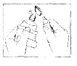
You can use things up instead of wasting them. Squeeze that last bit of toothpaste out of the tube. Use the last little piece of soap. Don't throw away any bits of the biscuit at the bottom of the box.
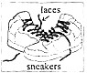
Wear It Out
You do not always need to have new things. Suppose your sneakers have broken laces, but they still fit you. Repair them and wear them longer. You don't have the latest iPhone until the old one doesn't work anymore. Then you can get a new one. Think twice before replacing something that still works.
Make It Do
When something you want is not on hand, look for something else that you already have to take its place. Suppose you are packing your lunch for tomorrow and want a butter sandwich. You are out of butter. Have a cheese sandwich instead so that you can use all of the cheese. Learn to fix broken toys instead of just throwing them away. With a little thought, you can make something do, instead of buying something new.
Do Without
Think about all those things that you would like to have. Do you really need them? How long will you really play with that new toy you saw on TV? Making the things that we want uses up your world's resources(资源). And, getting rid of the things we don't want any more takes up even more resources and space.
61. Do we need to be responsible for our environment?

62. How do we deal with the last little piece of soap?

63. When do we need to get a new iPhone?

64. What should we do when something we want is not on hand？

65. What does the writer want to tell us?

第四部分 写作技能（共三节，计35分）
第一节 翻译语篇 （5小题，计10分）
阅读下面的短文，然后将划线部分的句子译成汉语或英语。
Dear Amy,
It is very exciting that you are coming to our school so soon. 66.在你到来之前让我向你介绍一下我们学校。
67.Our school is quite famous for its long history. It was founded in the early 1920s. It is a good place where we can prepare ourselves well for the future. We have many wonderful teachers who are always ready to offer help. Though we pay a lot of attention to how well we do in lessons, 68.getting high grades is not the only reason to study. The teachers encourage us to try out new ideas and ask questions. With their help we have developed all kinds of interests in both Arts and Science. Students can choose to join any school clubs they are interested in.69.我们也可以选择自己想学的科目。I love my school and hope that you will have a pleasant experience here too. 70.我很期待尽快和你见面！

70.
第二节 完成对话 （5小题，计10分）
A: Hello, Betty. The examination is over. What are you going to do tomorrow?
B: I'm not sure. 71.________________?
A: I want to go to the Science Museum.
B: Why do you want to go there?
A: 72. ___________________,
B: That sounds interesting.
A: 73.______________________?
B: Yes, I'd love to.
A: Great! I'm sure we'll have a great time.
B: 74. ___________________? I want to take some photos.
A: I'm afraid you can't. We are not allowed to take photos inside the museum.
B: Got it. Oh, 75.____________________________?
A: At the gate of the museum. Be sure to get there before 9 o'clock.
B: OK. See you then.

- 情景作文（15分）

某英文报社举办以“I Like Reading”为主题的征文活动，你打算投稿。请根据以下要点写一篇短文：
1. 你为什么喜欢读书；
2. 你喜欢读哪一类的书（例如：历史、科学、文学等）？请给出至少两个理由。
注意：词数80左右。

2014年上学期九年级检测考试
英语试题（答卷）
(时间:90分钟 总分:150分)
听力(共20小题,计25分)
题号 | 1 | 2 | 3 | 4 | 5 | 6 | 7 | 8 | 9 | 10 | 11 | 12 | 13 | 14 | 15
答案

16. 17. 18. 19. 20.__________

单选(共15小题,计30分) .-
题号 | 21 | 22 | 23 | 24 | 25 | 26 | 27 | 28 | 29 | 30 | 31 | 32 | 33 | 34 | 35
答案

完形填空（共10小题,计20分）

题号 | 36 | 37 | 38 | 39 | 40 | 41 | 42 | 43 | 44 | 45
答案

阅读理解(共15小题,计30分)

题号 | 46 | 47 | 48 | 49 | 50 | 51 | 52 | 53 | 54 | 55
答案

56. 57. 58. 59. 60.

阅读答问(共5小题,计10分)

61.

62.

63.

64.

65.
翻译语篇（共5小题，计10分）

66.

67.

68.

69.

70.

补全对话(共5小题,计10分)

71.

72.

73.

74.

75.

书面表达（15分）
.
____________________________________________________________________________

____________________________________________________________________________

____________________________________________________________________________

____________________________________________________________________________

____________________________________________________________________________

____________________________________________________________________________

____________________________________________________________________________

第一节 听力选择
听对话，从题中所给的A、B、C三个选项中选出最佳选项。
听下面5段对话，根据相应对话做第1-5小题。
- M: I’m thirsty.
W: Have the watermelon then.
- W: Which animal do you like best in the zoo?
M: I like the panda best. They are lovely.
- M: Wow, you’ve changed. Well, you used to have short hair.
W: Yes, I did. Now I have long hair.
- M: Whose English book is this?
W: It must be Henry’s. It has his name on it.
- M: I don’t know what to wear.
W: If I were you, I’d wear a shirt.
听第六段对话，做第6-7小题。
W: Excuse me, Sam. Could borrow your bike ,please?
M: Certainly. What’s wrong with yours?
W: It doesn’t work.
M: Where are you going?
W: I’m going to the supermarket to buy some vegetables.
M: Can you buy some fruit for me, please?
W: Certainly. What fruit do you like?
M: Apples. Here’s the money. Thanks.
W: Thank you, too. But where’s your bike?
M: Over there. In front of the house.
W: Oh, I see it. See you later.
听第七段对话，做第8-9小题。
M: Rosa, what are you doing now?
W: I’m reading a storybook. What’s up, Ted?
M: May I use your DVD player?
W: For how long?
M: Till the end of this week.
W: OK, no problem.
M: Thanks. By the way, have you got any CDs?
W: Yes. They are over there. Help yourself.
M: It’s very kind of you.
听第八段对话，做第10-12小题。
M: Did you used to be afraid of the dark, Linda?
W: Yes, I did.
M: Are you still terrified of the dark?
W: No, I’m not. How about you?
M: Me? Oh, yes. I’m afraid of it.
W: So, what do you do about it?
M: I have to sleep with my light on.
听第九段对话，做第13-15小题。
M: Hi, Emma! I didn’t do well last term. And I failed my English exam.
W: Don’t give up, Jim. Let’s help each other and work harder.
M: OK. First let’s plan for the new term. I want to improve my English. What about you?
W: I plan to learn to play the piano this term. What’s Ann’s plan?
M: I know she plans to make the top ten in our class.
W; Tell her not to set the goals too high.
M: OK! Do you know Tom’s plan?
W: Yes. He plans to get a better grade in math this term.
M: Really? I want to study math with him. Can you tell him?
W: No problem. Well, let’s stop talking and start working now.
- 笔录要点
根据你所听到的内容，填写下面的表格，每空不超过3个单词。
Good afternoon. This is BBC news. On July 12, a tiger got free from a zoo and shocked people in a park in Spain. It happened on Saturday, and there were a lot of people in the park. It took the police over 20 minutes to catch the tiger. They then returned it to the zoo. Thankfully, nobody got hurt in the accident.
British people sent 3.19 billion text messages last month, says a recent report. This is more than 100 million messages each day. What surprising numbers! Are all British busy sending messages every day?
Thank you all for listening.
答案
1-5 AABBB 6-7 CC 8-9 CA 10-12 CCB 13-15 CBB
16. tiger 17. police 18. Nobody 19. 3.19 20. 100
21-35 CACBA BBCAC ABCCA
36-45 ABBCA BCCBA
46-55 BACCB CBBCA

56 Kinds / Types / Colors
57. blue
58. happy and satisfied
59. green
60. strong / powerful / strong and powerful

61. Yes, we do.
62. Use it up.
63. Until the old one doesn't work anymore
64. Look for something else.
65. Why and how to be responsible consumer.

66.Before you arrive, let me introduce my school to you.
67.我们的学校因为悠久的历史而闻名。
68.获得高分并不是学习的唯一理由。
69.We can also choose the subjects that we want to study.
70. I am looking forward to meeting you soon!

71. How about /What about you? What are you going to do? What do you want to do?
What's your plan?
72. Because there is /there will be ... Because I want to go to ..,
73. Would you like to go with me
74. Can/May/Could I take a camera with me
75. Where shall we meet

