2011年益阳市一中保送生考试
英语试题
时量：90分钟 总分：120分

I． 听力技能（共四部分，计25分）

- 听音选图 根据所听内容，选择相应的图画。 （共5小题，每小题1分计5分）
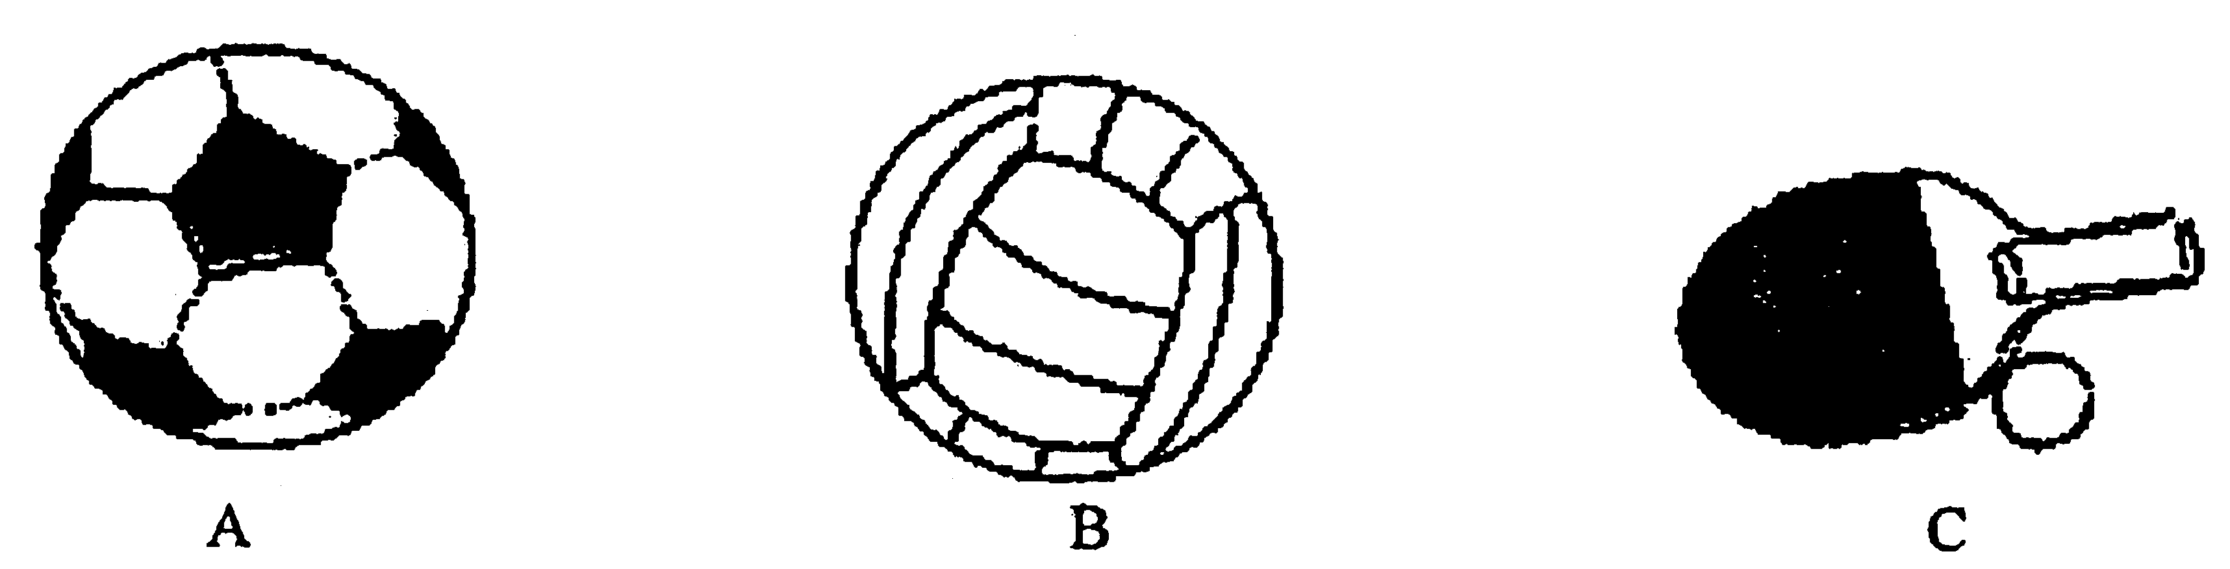
1.

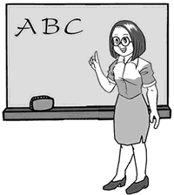
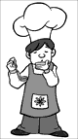


2.

A B C
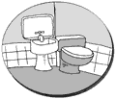
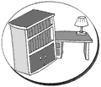
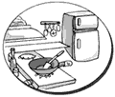
3.

A B C
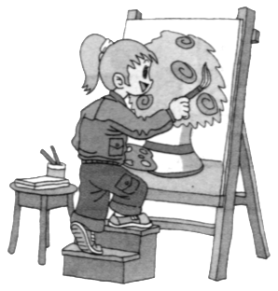
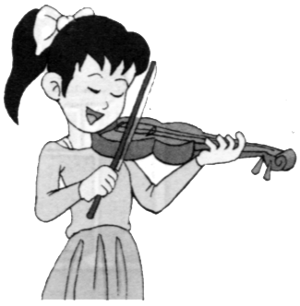
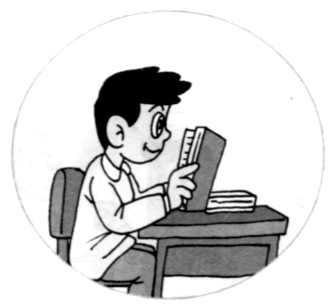
4.




A B C

5.

A B C

- 对话理解 根据你所听到的对话内容，选择正确答案。 （共5小题，每小题1分，计5分）
听下面一段对话，回答6-7小题。
（ ）6. How many people will go to Beijing?
A. Two. B. Eight. C. Four
（ ）7. When will the man travel to Beijing?
A. On July 21st B. On July 23rd. C. On July 22nd.
听下面一段对话，回答8-10小题。
（ ）8. Who will have dinner with the man?
A. Jack. B. Jane. C. John.
（ ）9. What will they have for dinner?
A. Sichuan food. B. Guangdong food. C. Hunan food.
（ ）10. When will they meet?
A. At 7:00. B. At 7:30. C. At 6:30.
C) 笔录要点 根据你所听到的内容，填写下面的表格。（共5小题，每小题1分， 计5分）
Telephone message
From: | 11.
What for: | his 12. meal
Meeting place: | at the gate of the restaurant
Time for the meal: | 13.
What to do at 2:30 : | go to 14. together
How to get there: | 15. there
- 反应 根据你所听到的句子内容和实际情况，写出简要答语。 （共5小题，每小题2分，计10分）
16.
17.
18.
19.
20.

II. 知识运用 （共两部分，计20分）
- 单项选择 （共10小题，每小题1分，计10分）
从所给A、B、C三个选项中选出可以填入空白处的最佳答案。
（ ）21. My father is _____ engineer, He works very hard.
A. a B. an C. the
（ ）22. --–Susan, is this your bike?
----No, it isn’t. is over there.
A. mine B. my C. me
（ ）23. ----Math isn’t as _ ____ as English.
----I agree with you. I think math is ______ than any other subject.
A. easier, difficulter B. easy, more difficult C. easy, easier
（ ）24. It is our duty our classroom everyday.
A. clean B. cleaning C. to clean
（ ）25. Don’t cross the street ______ the traffic lights are green.
A. until B. after C. when
（ ）26. _______ have you been playing the guitar?
A. How often B. How soon C. How long
（ ）27. Here is some _______, help yourselves to it.
A. tomatoes B. apples C. chicken
（ ）28. Lucy was born the night of May 12, 1984. . ...
A. in B. on C. at
（ ）29. Do you know _________?
A. where does she come from B. where she comes from
C. where is she from
（ ）30. Every year watch NBA on TV.
A. millions of people B. million people C. millions people

B) 完形填空 （共10小题，每小题1分，计10分）
通读下列短文，掌握其大意，然后从所给A、B、C三个选项中选出一个可以填入相应空白处的最佳答案。
These days，cars are designed by using computers．Let’s look at how a new car is created．
First，several 31 talk about the new car and any good ideas that they have．Then they sit down at their computers and 32 many sketches(草图、示意图qi)．The best two or three drawings are chosen and then more detailed drawings of 33 are developed on the computer．You can change the size，shape or color of any part on the computer to see 34 the car would look like and then you can choose the best design．
Both the inside and the outside of the car have to be designed．Part of the inside of the car is 35 so that the designers can sit in it．They can feel if there is enough 36 inside and if they can reach 37 ．Then some cars are built and there are more than 15，000 parts of a car to 38 ．
When everything is known to be 39 ，the cars are made in the factory．Again，computers are used to make sure that all the parts are 40 as they are needed．The factory
usually stays open all through the night so that the car production never stops．
（ ）31. A. drivers B. designers C. workers
（ ）32. A. draw B. order C. type
（ ）33. A. bicycles B. trains C. cars
（ ）34. A. how B. if C. what
（ ）35. A. covered B. built C. locked
（ ）36. A. metal B. glass C. room
（ ）37. A. nothing B. somebody C. everything
（ ）38. A. choose B. test C. show
（ ）39. A. safe B. easy C. cheap
（ ）40. A. ready B. electronic C. comfortable

III 阅读理解（共三部分，计40分）
- 判断正误（共5小题，每小题2分，计10分）
An important question about eating out is who pays for the meal. If a friend of yours asks you to have lunch with him, you may say something like this, “I’m afraid it’ll have to be someplace cheap, as I have little money.” The other person may say, “Ok, I’ll meet you at McDonald’s.”
This means that the two agree to go Dutch, that is, each person pays for himself. He may also say, “Oh, no, I want to take you to lunch at Smith’s,” or “I want you to try the Chinese dumplings there. They are great.” This means the person wants to pay for both of you. If you feel friendly towards the person, you can go with him and you needn’t pay for the meal. You may just say, “Thank you. That would be very nice.”
American custom about who pays for dates are much the same as in other parts of the world. In the old days, American women wanted men to pay for all the meals. But, today, a university girl or a woman in business world will usually pay her way during the day. If a man asks her for a dance outside the working hours, it means “Come, as my guest.” So as you can see, it is a polite thing to make the question clear at the very beginning.
（ ）41. The passage tells us what to eat out.
（ ）42. If you have little money, you’ll have a cheap meal.
（ ）43. “Go Dutch” in this passage means a person wants to pay for both of you.
（ ）44. Sometimes your friend takes you to lunch. It means he’s going to pay for your meal
（ ）45. In America, some girls and women try to pay for the men’s meals now.

- 选择答案 （共10小题，每小题2分，计20分）
（A）
A little boy invited his mother to attend his elementary school’s first teacher-parent meeting. To the little boy’s dismay (沮丧), his mother said she would go. This would be the first time that his classmates and teachers met his mother and he was embarrassed by her appearance. There was a severe (严重的) scar (伤疤) that covered nearly the whole right side of her face. The boy never wanted to talk about why or how she got the scar.
At the meeting, the people were impressed by the kindness of his mother with the scar, but the little boy was still embarrassed and hid himself from everyone. However, he could hear clearly the conversation between his mother and the teacher.
“How did you get the scar on your face?” the teacher asked.
The mother replied, “When my son was a baby, he was in a room that caught on fire. Everyone was too afraid to go in because the fire was out of control, but I went in. As I was running towards his bed, I saw a burning wood falling down and I placed myself over him trying to protect him. I was knocked to be unconscious (无知觉的), but luckily, a fireman came in and saved both of us.” She touched the burned side of her face. “This scar will be forever, but until today, I have never regretted doing what I did.”
When the little boy heard this, he couldn’t help running towards his mother with tears in his eyes. He hugged her and felt his mother was greater than anyone. He held her hand tightly for the rest of the day.
根据短文内容，从各题所给A、B、C三个选项中选出最佳答案。
（ ）46. The boy’s mother was actually _____.
A. kind B. beautiful C. ugly but kind
（ ）47. According to the passage, the little boy ________.
A. didn’t ask his mother to attend the meeting
B. didn’t really want his mother to attend the meeting at first
C. wasn’t moved by what her mother said
（ ）48. After reading the passage, we know _______.
A. the people at the meeting didn’t like the boy’s mother
B. the boy hated what his mother had done
C. we should respect our parents whatever they are like
（ ）49. Was the little boy moved by his mother?
A. Yes. B. No. C. We don’t know.
（ ）50. What did people at the meeting think of the little boy’s mother?
A. The people didn’t like her.
B. The people were impressed by the kindness of his mother with the scar.
C. They felt embarrassed.
（B）
Some unusual words describe how a person spends his or her time. For example, someone who likes to spend a lot of time sitting or lying down while watching television is sometimes called a "couch potato". A couch is a piece of furniture that people sit or lie on while watching television.
Couch potatoes enjoy watching television just as "mouse potatoes" enjoy working on computers. A computer mouse is the device(装置，设备) that moves the cursor（光标）on a computer screen. American writer Alice Kahn is said to have invented the word to describe young people who spend a lot of time using computers.
Some people enjoy spending a lot of time in their homes to make them nice places to live. This is called nesting or cocooning. They describe people buying their first homes and filling them with many things. These people then had children. Now these children have grown up and have left the nest. They are in college. Or they are married and starting families of their own far away. Now these parents are living alone without children in their empty nest. They have become empty nesters.
（ ）51. What is a couch potato?
A. Someone who likes sitting or lying down while watching TV.
B. Someone who likes potatoes.
C. Someone who watches TV.
（ ）52. What is the Chinese meaning of the word "couch"?
A. 床 B. 沙发椅 C. 凳子
（ ）53. What is a mouse potato?
A. A mouse that eats potatoes.
B. A potato which looks like a mouse
C. Young people who spend a lot of time using computers.
（ ）54. Which of the following is NOT true?
A. A computer mouse is the device that moves the cursor（光标）on a computer screen.
B. Couch potatoes and mouse potatoes are people.
C. The writer of the passage doesn't like potatoes.
（ ）55. What can we learn from the passage?
A. Nesting or cocooning means that people like to buy many houses.
B. These children leave their homes because they don't like to live with their parents.
C. Parents living alone without children are empty nesters.

- 回答问题 （共5小题，每小题2分，计10分）
A report says the number of micro-blog(微博) users in China is over 120 million. There will be more users in 2012. Micro-blogging started in the early 2010 in China, and 125.217 million people are using it in October.
With micro-blogs, it is easier to give and get new ideas. In 2010, people knew 11 big events first on micro-blogs. For example, "Li Gang is my father" was one of them.
Radio took 38 years to attract 50 million people. TV took 13 years. The Internet used 4 years. But it took micro-blogs only 14 months to reach such a number.
However, some think micro-blogs are sometimes a waste of time. Some news on them is like trash, and sometimes you get nothing after you read five pages.
56. When did micro-blogging start in China?
57. How many people are using micro-blogs in October?
58. Is it difficult to give and get new ideas with micro-blogs?
59. How long did micro-blogs take to attract 50 million people?
60. What do some people think some news on micro-blogs like?

IV 写作技能 （共三部分，计35分）
- 翻译句子（每空1分，计10分）
根据所给汉语，完成下列英语句子，每空一词。
61. 我此刻感觉不舒服。
I don’t at the moment.
62. 他昨晚直到午夜才回来。
He _____ come home ______ midnight.
63. 我不喜欢离开太长时间。
I don’t like ______ _______ for too long.
64. 今年我打算在课堂上练习说英语。
I’m going to ______ English in class this year.
65. 除了我之外，其它每个人都被邀请了。
Everyone _________ was invited, _________ me.

- 完成对话 （共5小题，每小题2分，计10分）
通读下列对话，然后根据上下文补全对话内容。
A: Excuse me, _(66)_____________________ ? I haven’t seen him for weeks.
B: Jim’s gone to England.
A: Really? _(67)____________________ ?
B: He went there last week.
A: _(68)_________________________ ?
B: Yes. He had lived there for 15 years before he came to China.
A: _(69)__________________________ ?
B: He traveled with his friends.
A: _(70)__________________________ ?
B: He’ll be away for about two weeks.
A: Oh, thank you. I’ll phone him this evening.

- 作文（计15分）
初中生活即将结束, 你即将迎来全新的高中生活。为了尽快适应环境，你需要制定一个新的计划，谈谈你在高中会遇到的问题，并向朋友们寻求帮助。
要求：1.字数：60-80字
2. 短文中不得出现真实的人名，校名和地名。

