益阳市2017年普通初中毕业学业考试试卷
英 语
考生注意：1．本学科试卷分试题卷和答题卡两部分；
2．请将姓名、准考证号等相关信息按要求填涂在答题卡上；
3．请按答题卡上的注意事项在答题卡上作答，答在试题卷上无效；
4．本学科为闭卷考试，考试时量为90分钟，卷面满分为120分；
5．考试结束后，请将试题卷和答题卡一并交回；
6．试卷中听力材料以中速朗读两遍；选择题中最佳选项只有一个，
不选、多选、错选、涂写不清楚，均不给分。
试 题 卷
I．听力技能（三个部分，共20小题，计25分）
A）听音选图（共5小题，计5分）
根据你所听到的内容，选择相应的图片。
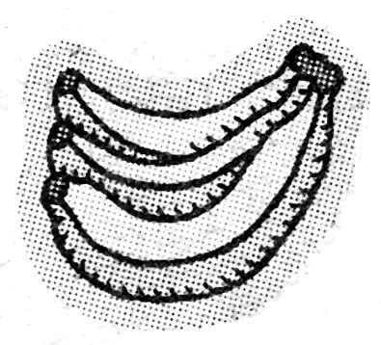
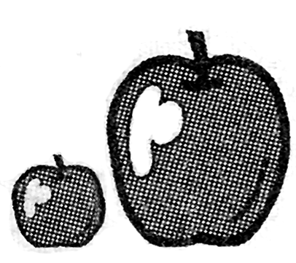
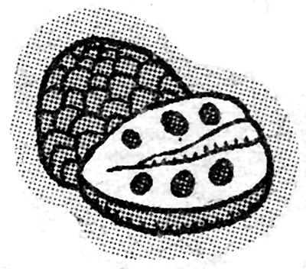
1．A． B． C．

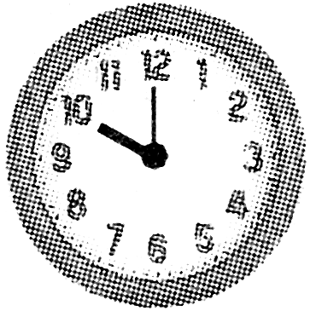
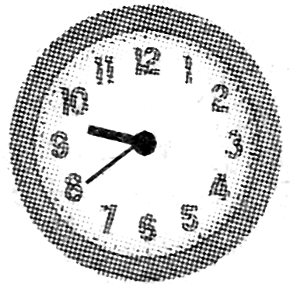
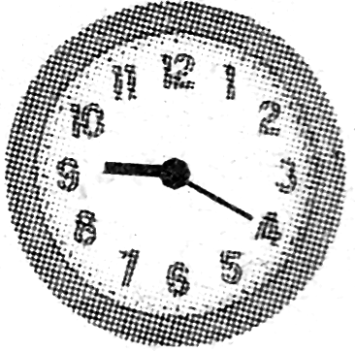
2．A． B． C．

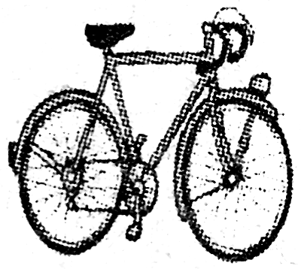
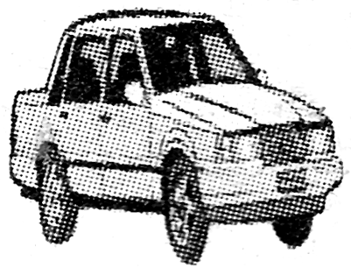
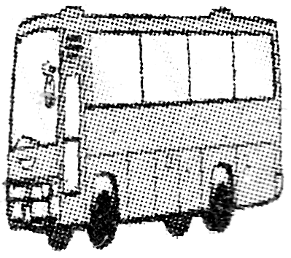
3．A． B． C．

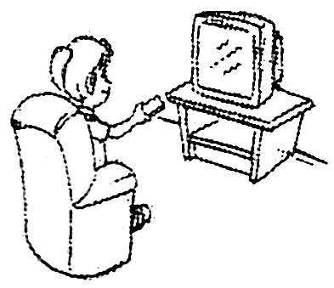
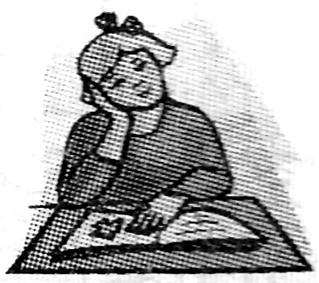
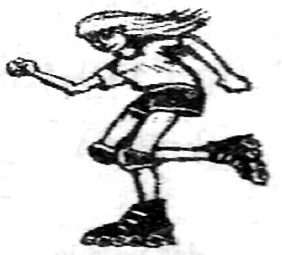
4．A． B． C．



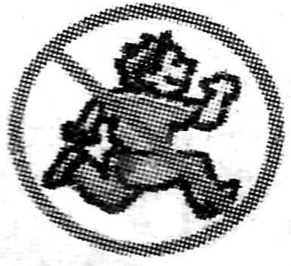
5．A． B． C．

B）对话理解（共10小题，计10分）
根据你所听到的对话以及针对该对话所提的问题，选出能回答该问题的最佳答案。
听下面一段对话，回答第6小题。
6．What does the boy want to be in the future?
A. A policeman. B. A doctor. C. A teacher.
听下面一段对话，回答第7小题。
7．What will the weather be like tomorrow?
A. Sunny. B. Cloudy. C. Rainy.
听下面一段对话，回答第8小题。
8．Which country is John from?
A. England. B. Australia. C. Canada.
听下面一段对话，回答第9小题。
9．How many people spoke at the class meeting?
A. Six. B. Five. C. Four.
听下面一段对话，回答第10小题。
10．What subject does Jack like best?
A. Physics. B. English. C. Math.
听下面一段对话，回答第11-12小题。
11．Why is the boy sitting on the ground?
A. Because he was tired.
B. Because he fell off the bike and hurt his leg.
C. Because he had a stomachache.
12．What is the girl going to do for him?
A. She is going to take him home.
B. She is going to call the police.
C. She is going to call his mother.
听下面一段对话，回答第13-15小题。
13．When did David go to the zoo?
A. Last Saturday. B. Last Sunday. C. Last Monday.
14．Who drove the car?
A. Frank’s father. B. Frank’s friend. C. Frank.
15．How did David like the animal show?
A. It was scary. B. It was awful. C. It was great.
C）笔录要点（共5小题，计10分）
根据你所听到的内容，完成下面的表格。（每空不超过三个单词）
People Sports Center
Service | It offers service for 16. ______.
Outdoors | A baseball field, two football fields and a 400 – meter 17. ______.
Indoors | You can play basketball and table tennis. You can also enjoy 18.______.
Free tickets | Children under 19.______ years old can get.
Open hours | It opens 20.______.
II．知识运用（两个部分，计20分）
A）选择填空（共10小题，计10分）
从A、B、C三个选项中选出一个可以填入空白处的最佳答案。
21．I bought ______ useful dictionary yesterday. _______dictionary is very cheap.
A. a; A B. a; The C. an; The
22．—Is this your son’s sweater?
—No, ______ is on the chair behind the desk.
A. hers B. yours C. his
23．—Which of the two subjects do you like, P.E. or music?
—_______. They are really interesting.
A. Neither B. Both C. None
24．I didn’t realize he was a famous scientist ______ you told me.
A. until B. because C. since
25．It’s necessary for you _______the classroom clean, class.
A. keep B. keeping C. to keep
26．The number of people in the city ______ about seven million now.
A. are B. has C. is
27．If more people give up driving cars, the air will get much _______ in a few days.
A. clean B. cleaner C. the cleanest
28．The school sports meeting will be_______ because of the heavy rain.
A. put up B. put on C. put off
29．—I wonder if Tom______ this afternoon.
—Don’t worry. I will tell you as soon as he_______.
A. will come; comes B. comes; will come C. comes; comes
30．Could you please tell me _______ ?
A. how old are you B. when he will come back C. where is he from
B）完形填空（共10小题，计10分）
通读下面的短文，然后从短文后所给的A、B、C三个选项中选出最佳答案填空，使短文完整通顺。
Smiling is the best way of making friends. When I was thirteen 31 old, my father found a job in the city. So my family moved there. I also came to a(n) 32 school near where we live. My old school was far away. At first, I didn’t know anyone in my class. I was very lonely 33 I was afraid to make friends with my classmates. I 34 talk to anyone about my problem, and I didn’t want my parents to 35 me.
Then one day, something good happened. I was sitting at my desk unhappily as usual while my classmates were talking 36 with each other. At that moment, 37 came into the classroom. I didn’t know who he was. He passed me and then turned back. He looked 38 me and smiled. Suddenly, I felt happy and warm. That smile changed my life. I started to talk with the other classmates and made friends. Day by day, I became closer to everyone in my 39 .
Thanks to the 40 . I have moved on to a new life. Now, I believe that the world is what you think it is. So smile to the world and it will smile back.
31．A. weeks B. months C. years
32．A. old B. new C. open
33．A. because B. before C. after
34．A. couldn’t B. mustn’t C. needn’t
35．A. talk to B. ask for C. worry about
36．A. happily B. unhappily C. loudly
37．A. a girl B. a boy C. a friend
38．A. into B. like C. at
39．A. family B. class C. city
40．A. sadness B. life C. smile

III．阅读技能（共两个部分, 计40分）
A）阅读下面三篇材料，从每题所给A、B、C三个选项中选出最佳答案。（共15小题，计30分）
A
Yunmeng Water Park  Ticket Price: 80yuan on weekdays  100yuan on weekends  Opening Time: 10:00a.m.—3:00p.m.  Tel: 8595885 | Volunteers Wanted  Can you speak English well? Can you work hard? Do you know much about Beijing? Do you want to work as volunteers?  Age: 20—50 Please call: 8951568
Found  A sports bag. It’s black.  There is a basketball, a pair of sports shoes in it.  Come to Classroom 201.  Tel: 3215535 | Movies in Dadi Cinema Today  Titanic : 8:00a.m.—10:00a.m.  Spider-Man: 2:00p.m.—4:00p.m.  Kung Fu Panda: 6:00p.m.—8:00p.m.  Ticket price:￥25  Booking office: 8601002
41．If you want to pay less money in Yunmeng Water Park, you can go there on_________.
A. Monday B. Saturday C. Sunday
42．The owner of the sports bag may be good at playing __________.
A. baseball B. volleyball C. basketball
43．Tom wants to be a volunteer, he should call__________.
A. 8601002 B. 8951568 C. 8595885
44．Lin Tao can be a volunteer because he speaks________ well.
A. French B. Chinese C. English
45．Mr. Brown won’t be free until 4:30p.m. Which movie can he see?
A. Spider-Man. B. Kung Fu Panda. C. Titanic.
B
Last Saturday afternoon, my friend Mr. Li took his two little boys to play tennis. He walked up to the young man at the ticket office and asked, “How much is it to get in?”
The young man answered, “3 yuan for you and 3 yuan for any kid who is older than six. We let them in free if they are six or younger. How old are they?”
Mr. Li said, “Li Ming is six and Li Hua is seven, so I think I should pay 6 yuan.”
The man at the ticket office said, “Hey, you are too honest. You can save yourself three yuan if you tell me that the older one is six. I don’t know the difference.” Mr. Li said, “Yes, that may be true, but the kids know the difference.”
When ethics(道德规范)are more important than ever before, make sure you set a good example(榜样)for everyone you work and live with.
46．What did Mr. Li and his sons want to do?
A. To play tennis. B. To do some shopping. C. To go fishing.
47．If Mr. Liu and Mrs. Liu take their 3-year-old son and 10-year-old daughter to play tennis, how much should they pay?
A. 6 yuan. B. 9 yuan. C. 12 yuan.
48．Who do the words “the older one” in paragraph 4 refer to(指的是)？
A. Mr. Li. B. Li Ming. C. Li Hua.
49．Which of the following is TRUE?
A. Mr. Li wanted to save three yuan．
B. We should set a good example for our children.
C. The man at the ticket office wanted Mr. Li to pay 9 yuan.
50．What’s the best title(标题) of this passage?
A. Playing Tennis Is Interesting
B. A Father and His Two Sons
C. What You Are Is as Important as What You Do
C
Do you like traveling? Here is some advice.
● Always wear your most comfortable clothes when going on long journeys.
● Traveling on trains or buses can be boring, so take a good book to read.
● If you are going somewhere sunny, remember to wear sunblocks(防晒霜）and sunglasses.
● Always take a camera with you to capture those special moments.
● Be careful with your things whenever you go to busy places, like a train station. There are often thieves there.
● Most countries have lower prices for students, so if you have one, take your student card with you and save money.
● If you travel abroad, remember to take your passport, Whatever you do, don’t lose it!
51．If you go to Hainan Island for a trip in summer, you should take ______with you.
A. some fruit and drinks B. warm clothes and sports shoes
C. sunglasses and sunblocks
52．According to the passage, _____ is a good way to keep away from boredom(单调).
A. reading a good book B. taking a camera C. listening to music
53．You must always _______ because there are often thieves at some busy places.
A. put your things down B. look after your things well
C. take few things with you
54．If a student shows _______ to the shop assistant, he can buy some presents at lower prices while traveling.
A. his things B. his passport C. his student card
55．The underlined word “capture” in this passage means ________.
A. 感受 B. 拍摄 C. 控制
B）回答问题（共5 小题，计10分）
阅读下面的短文，然后根据短文内容回答问题。
The sun is always shining. But it can only shine on one side of the earth at one time. When the sun is shining on one side of the earth, it is night on the other side. At night, you can see the stars. The stars are in the sky all day. But the light from the sun is so bright that you can’t see them. When night comes, there is no light, and the stars are bright enough to see. The stars look very small. But some of them are even bigger than the sun. They look small because they are so far away from you. Big things look much smaller when they are far away. The sun is closer to the earth than other stars, so it looks bigger.
56．Can the sun shine on only one side or two sides of the earth at one time?
57．Are the stars in the sky all day?
58．When are the stars bright enough to see?
59．How do big things look when they are far away?
60．Why does the sun look bigger than other stars?
IV. 写作技能（三个部分，共10小题和一篇作文，计35分）
A）摘录要点（共5小题，计10分）
阅读下面的材料，然后在表格中完成内容摘要，每空不超过三个单词。
Paper Cutting and Sky Lanterns
Paper cutting has been around for over 1,500 years. Paper cutting is difficult to do. The paper, usually red, is folded before it is cut with scissors. The most common pictures are flowers, animals and things about Chinese history. During the Spring Festival, they are put on windows, doors and walls as symbols of good wishes and a happy new year.
Sky lanterns were first used by Zhuge Kongming. He sent them out to ask for help when in trouble. Today, sky lanterns are used at festivals and other celebrations. When the lanterns are lit, they slowly rise into the air like small hot-air balloons for all to see. They are seen as bright symbols of happiness and good wishes.
Paper Cutting and Sky Lanterns
History of paper cutting | over 61.______
The most common pictures | flowers, 62. ______ and things about Chinese history
Purpose of sending out  63. ______ | ●to 64. ______ when in trouble  ●used at festivals and other celebrations today
Common symbols | 65. ______ and happiness
B）完成对话（共5小题，计10分）
通读下面的对话，然后根据上下文补全对话内容。
A: Hi! Excuse me.
B: Yes. What can I do for you?
A: I’d like to go to Yiyang Museum. 66. _________________?
B: It’s on Kangfu Road.
A: Oh, 67. _________________?
B: It’s about 4 kilometers away. You’d better take the bus there.
A: 68. _________________?
B: You can take No.8 bus.
A: 69. _________________?
B: It will take you about 15 minutes.
A: Well, is the museum on the right ?
B: 70. _______________. It’s on the left. It’s between the post office and the bank.
A: Thanks a lot.
B: You’re welcome.
C）作文（计15分）
暑假即将来临，许多学生喜欢下河游泳。为预防游泳溺水事故的发生，你们班将举行以“珍爱生命，预防溺水”为主题的班会。请你用英语写一篇发言稿，谈谈你对安全游泳的建议。建议内容包括：不要到陌生的河流湖泊游泳；不允许擅自结伴游泳；不会游泳，不要下水救人……
要求：1．语言通顺，意思连贯，符合逻辑。
2．内容可适当发挥。
3．文中不得出现真实的校名和人名。
4．词数：70词左右。
参考词汇：alone without permission（未经许可） allow
ask for help cherish（珍爱）
Going Swimming Safely
______________________________________________________________________________________________________________________________________

