2016年益阳市一中“珍珠班”招生考试
英语试题
时量：90分钟 总分：120分
第一部分: 听力技能 (共两节，计25分)
第一节 听力选择 ( 15小题，计15分)
根据你听到的对话，选择正确的答案回答问题。
听下面5段对话，每听完一段对话后，做1个小题。
( )1. What does Ann’s father do?
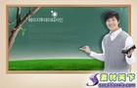


A. B. C.

( )2. Where would Sam like to visit?
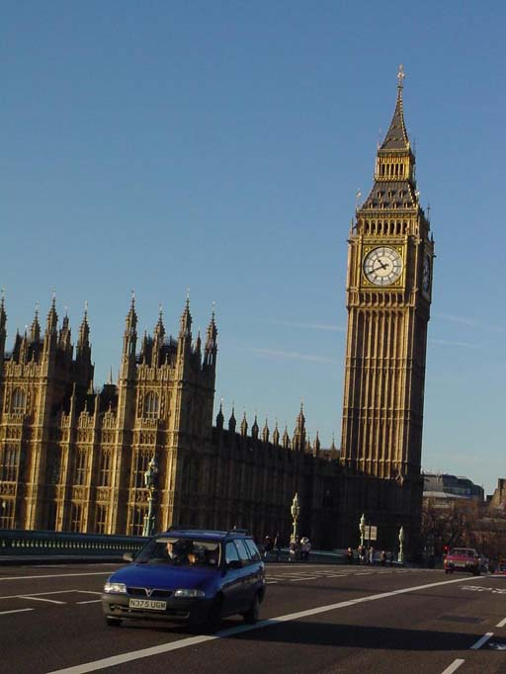
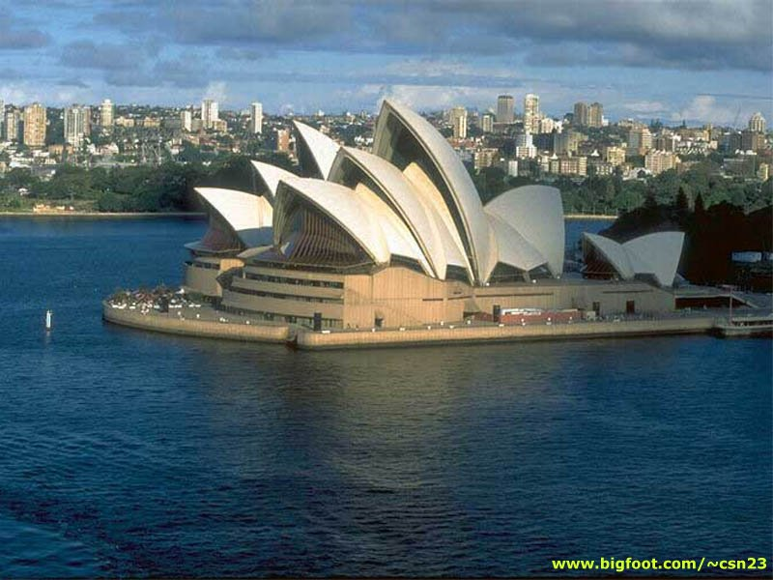
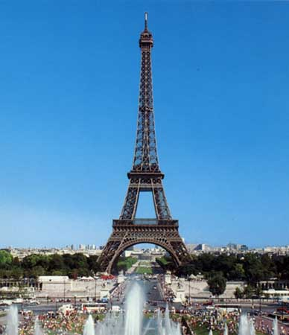
A. B. C.

( )3. Who has the CD player now?
A. Alice. B. Linda. C. Mary.
( )4. How does the boy like the film?
A. It's boring. B. It’s exciting. C. It's interesting.
( )5. What time did Kate leave for school?
A. At 6:45. B. At 7:15. C. At 7:00.
听第六段对话，做第6-7小题。
( )6. What is the boy’s favorite food?
A. Fish. B. Beef. C. Pork.
( )7. When may this conversation happen?
A. At noon. B. In the morning. C. In the evening.
听第七段对话，做第8-9小题。
( )8. Who is Jenny going to the movies with?
A. Her mother. B. Her brother. C. Her sister.
( )9. What will Tom do this afternoon?
A. Watch a soccer game. B. Study for a test. C. Go to a movie.
听第八段对话，做第10-12小题。
( )10. Why is Tom going to Paris?
A. Because he’s got a new job there. B. Because he’s got married.
C. Because he’s got a friend there.
( )11. How will they communicate with each other ?
A. By phone. B. By QQ. Ｃ. By letter.
( )12. When is the best time for the woman to surf the Internet ?
A. After 7:00 a.m. B. After 7:00 p. m. Ｃ. After 9:00.
听第九段对话，做13-15小题。
( )13. What time did the girl call Tom?
A. At 7:00 yesterday evening. B. At 7:00 this morning.
C. At 7:00 yesterday morning.
( )14. What did Tom do last night?
A. Went to a concert. B. Had the piano lesson.
C. Sang in the theatre.
( )15. Why was the concert held?
A. To set up a new theater. B. To build new schools for the students
C. To raise money for the poor people .

第二节：笔录要点（5小题，计10分）
根据你所听到的内容，填写下面的表格，每空不超过3个单词。
Weather Report
City | Weather | Activity
16 | Sunny, cloudy, warm | 17.
Guangzhou | 18 | Having a swim
Taiyuan | Cool and windy | 19
Shanghai | 20 | Having a picnic.

第二部分 知识运用（共两节 计50分）
第一节 语法填空 ( 15小题，计30分)
从A、B、C三个选项中选择正确的答案填空。
( ) 21. ---This pair of shoes is too small for me. Could you please show me ______? ---OK.
A. the other one B. another pair C. another one
( ) 22. Mr Li asked Tom ________ a moment ago.
A. what is wrong B. what the trouble was C. what was the matter
( )23. The little boy ______ his hands before meals by his mother every day.
A．makes to wash B．is made washing C. is made to wash
( ) 24.Our chairman got to the farm the morning of May 8th and he stayed there ____two days.
A. in, for B. on, for C. in since
( ) 25.---Your dress is so nice. How long______ you ___ it? ---For five months.
A. have, bought B. did, buy C. have, had
( ) 26---I haven’t seen you for a long time. You look fine. ---________.
A. Thank you B. Don’t say that C. Not at all
( ) 27.—Have you ever been to the Ocean Park ?----Yes, I______ there last term.
A. have been B. have gone C. went
( )28. These volunteers would try their best to do as much as they could .
A. to help the homeless kids B. help the homeless kids C. helped the homeless kids
( )29. As we all know Kunming is regarded as “Spring City”. The weather there is much better than in Hunan.
A. what B. that C. which
( ) 30. As we all know three fourths of the members over there and most of the work over. .
A. is , are B. are ,is C. is , is
( )31.—Jim does well in Chinese in our class. — .No one does better than him.
A. So do I B. So he does. C. So does he.
( )32.—It’s a secret between you and me. Don’t tell anybody. —Sure,
A.I won’t B.I don’t C.I will
( )33.Now the air in our city is than it used to be. Something must be done to stop it.
A. very good B. much better C. even worse
( )34.Helen came back to the village she reported 3 years ago.
A. where B. what C. which
( ) 35. role she played in the film! No wonder she has won an Oscar.
A. How interesting B. What an interesting C. What interesting
第二节 词语填空 ( 10小题，计20分)
通读下面的短文, 掌握其大意, 然后从各题所给的A、B、C三个选项中选出一个最佳答案。
Have you ever seen Sea-maiden (美人鱼) ？It’s a popular movie this year . It’s three-dimensional (3D), so you may have to wear a （36） pair of glasses to see it . The 3D glasses make the images (图像)from the movie look like they are coming （37） at you .
More and more 3D movies are coming to theatres. Some say that 3D TV sets will come into our（38） in the near future .Three-dimensional technology can make TV and movies more exciting . But people with （39） problems may get headaches if they spend too much time watching 3D movies. Why ?When we look at an object, each eye sees it at a different angle . Our eyes send the two images to our brain, and the brain puts them together That’s （40） we see depth(深度) .
Three-dimensional technology uses two film projectors (投影机) . One projects a left eye image and （41） projects a right eye image . 3D glasses allow us to see a different image （42） .
There are a lot of people walking around with very minor eye problems, for example an eye muscle imbalance (眼肌不平衡) . Under normal situations , the brain can adjust to their eyes so they can see things clearly .But when they are watching a 3D movie , the images projected to their eyes can’t be put together by their（43） .So the brain needs to work harder at “（44） ” the images. That makes it（45） for those people to get dizzy or develop headaches.
( )36. A. common B. new C. special
( )37. A. straight B. near C. quickly
( )38. A. libraries B. offices C. homes
( )39. A. head B. eye C. ear
( )40. A. why B. how C. when
( )41. A. another B. others C. the other
( )42. A. in each eye B. in the right eye C. in the left eye.
( )43. A. eyes B. images C. brain
( )44. A. seeing B. watching C. reading
( )45. A. easier B. more difficult C. hard

第三部分 阅读技能（共三节，计40分）
第一节 阅读选择 ( 10小题，计20分)
阅读下面的短文，从每题所给的A、B、C三个选项中，选出最佳选项回答问
题或完成句子。
A
Look at that beautiful picture .It was a seagull (海鸥) that took the picture .Whether you believe it or not, I’m telling you the truth.
The seagull took away a camera from a 26-year-old woman called Nathalie Rolland. She is from France and she went to America for travelling. At that time, she was standing at the Golden Gate Bridge and taking photos of the sunset. Suddenly, a seagull took her camera and flew away. The camera was still on. Nathalie ran around the beach after the seagull and wanted to get back her camera. She wanted to lose neither the camera nor the photos taken by her. She felt worried and asked other tourists if they saw a seagull with a camera in its mouth. The bird flew over the water for about 60 seconds, and then dropped the camera on a walkway. To her surprise, when she finally got her camera back, she found the seagull had taken a wonderful video from a special bird’s angle.
After she went back home, she put the video on the website, YouTube. It has got tons of attention and won lots of people’s praise. People thought the photo the seagull took was so special. From the photo, we can see the unusual world in the seagull’s eyes.
( )46．What was Nathalie doing when the seagull took away her camera?
A．She was taking photos of the bridge.
B．She was taking photos of the sunset.
C．She was playing with birds.
( )47．According to the passage, Nathalie found her camera ________．
A. on the bridge B．on the beach a Chinese dragon C．on the walkway
( )48．After reading the passage, we can infer（推断） YouTube is ________ .
A. a website B．a traveling club C. a video
( )49．Which of the following is true according to the passage ?
A . A number of people were interested in the photo that the seagull took.
B. Nathalie is a 26-year-old American .
C. The surprising story happened in France .
( )50．What is the best title of the passage ?
A．Travelling around the USA.
B．A careless woman .
C．The unusual photo .

阅读下面的图表，做51-53小题
A part-time assistant wanted
We are looking for an adult woman to work as part-time assistants at the weekends. Your job is to give customers information on the Internet. Please call Mr Wang at 345289021 from 9:00 to 18:00 .
( )51. Which is true ?
A. If you want to get more information, you can send an email to Mr Wang.
B. If you get the job , you may work 8 days a month .
C. You can call Mr Wang at 10:00 pm.
( )52.If you get the job and you can get 40 yuan a day , how much will you get in a month ?
A. 600 yuan B. 160 yuan C. 320 yuan
( )53.Who may succeed if they apply for（申请) the job ?
A. Mrs Black is a clerk who works from Monday to Friday in an office .
B: Mr Liu likes to talk with others and he is good at the computer.
C: Li Hong is a 16-year-old student and she likes to surf the internet.

阅读右边的图表，做53-55题
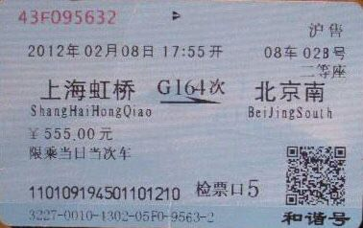
( ) 54. Look at Lin Tao’s high-speed train
ticket ,which of the following is true ?
A. Lin Tao paid 200 yuan for the ticket.
B. This high-speed train was from Beijing
to Shanghai .
C. This was a ticket for the second class seat.
( )55.When did the train leave the station?
A. On November 8 th, 2012.
B. At 5:55 pm.
C. In the morning.
第二节 摘录要点 ( 5小题， 计10分)
阅读下面的材料，然后在表格中完成内容摘要，每空不超过三个单词。
Different countries have different cultural customs（习俗）. This December we’ll welcome guests（客人） from all over the world. Some of them follow their own special cultural traditions. It’s important for us to know about them.
In many countries, such as Thailand, India and Malaysia , people believe that the left hand is unclean. So it’s not right to use one’s left hand to hold food, touch others or pass things .Doing so may offend（冒犯） certain guests.
You may also offend some westerners if you touch them or touch their personal things---even by accident .If this happens ,say sorry politely. Some elderly westerners may be offended if you try to help them without their agreement. People also think numbers can be lucky and unlucky .Some westerners avoid(避免) the number 13 because they believe it is unlucky.
Muslim(穆斯林)countries do not eat pork, and words like pigs are not considered proper.
People from Brazil ,Italy and Pakistan don’t give handkerchiefs（手帕） as gifts. They think a handkerchief can bring unhappy feelings.
Wine is not sent as a gift in many parts of western and middle Asia .

Title (标题)： 56
Countries | Customs
Thailand, India and Malaysia | 57. ,touch others or pass things with the left hand.
58. | Don’t touch them or their personal things.  Help the elderly with their agreement  Avoid the number 13.
Muslim countries | Don’t eat pork and don’t use words like pigs.
Brazil ,Italy and Pakistan | Don’t give handkerchiefs as 59._______.
Some western and middle Asian countries | 60. as a gift.

第三节 回答问题 ( 5小题计10分)阅读下面的材料，然后根据材料内容回答问题。
While planes get us to our destination（目的地）quickly, we miss some fantastic scenery along the way. A long train ride allows us to enjoy more relaxing time on the road. Here, we introduce some of the most popular railway trips . Just book a ticket, pack your backpack, and set off.
Road into the clouds : from Xining, Qinghai to Lhasa, Tibet ; 23 to 24 hours. As the highest railway in the world, the Qinghai-Tibet railway climbs to 5,000 meters above sea level. Since 2006, millions of visitors have been there .On the way, you can enjoy the beautiful Qinghai Lake and the grand Kunlun Mountains. If you are lucky enough, you may even see Tibetan antelopes(羚羊) and other wild animals running .
Road through history: from Xi’an, Shaanxi to Dunhuang, Gansu; 22 to 23 hours. From Xi’an, the beginning of the ancient Silk Road to Dunhuang, this is a trip through China’s history. The relics（遗迹） of the Great Wall in the Ming Dynasty(朝) and the Qilian Mountains are worth seeing. In Lanzhou, you can see the Yellow River going through the city. Then you can pass through the long Hexi Corridor by train.,
Trip for all seasons: from Shenyang, Liaoning to Manzhouli; 22 hours. This route goes into the cold northeast parts of China. In winter, the endless forests covered with snow are very fascinating. In summer, it’s a good choice to escape the heat. At every stop, tourists can get off the train to experience the deep snow.

61. When was the Qinghai-Tibet railway built ?
62.Which route can you know more about Chinese history ?

63.Can the visitors see the special wild animals on the way to Lhasa sometimes ?

64. How long does it take from Shengyang to Manzhouli by train ?

65. What do you think of traveling by train ?

第四部分 写作技能（共三节，计30分）
第一节 翻译语篇 （5小题，计10分）
阅读下面的短文，然后将划线部分的句子译成汉语或英语。奥思特
In the first week after arriving in the new city for further study, I fell and broke my leg. 66..我真的被我的新室友的友好感动了 “We are family now,” she said when she found me lying in my room with a swollen(浮肿的) leg, unable to move. She took me to the nearest hospital by taxi to get my leg examined. The driver was so kind that we arrived there very quickly. 67.After that, my roommate didn’t stop helping me though I told her I could do things on my own.
68.So many blessings(幸事) I had never expected came to me when I was alone and helpless. Bus drivers picked me up from anywhere they saw me. Many people opened the door for me. Such things were small but hard for a person on walking sticks(拐杖).
In return people’s kindness, 69.我尽我的所能让我周围的人笑起来 . I made many jokes about my two sticks and the bad fall. And I tried not to complain a single time about what had happened. I also tried to be kind to other students who were injured. 70.I took time to chat with a girl in a wheelchair who always ate lunch alone.
I soon realized that pain can be reduced by mental (精神上的) power. I could see that although I was using physical sticks, there were hundreds of mental sticks I could depend on. I also saw that sometimes unpleasant situations could be good. There are choices to discover great kindness in the world.
66.

第二节 完成对话 （5小题，计10分）
根据下面的对话情景，在每个空白处填上一个适当的句子，使对话的意思连贯、完整。
A： 71 ？
B: I have a headache.
A: 72 ?
B: Since three days ago.
A: 73 ?
B: No, I didn’t take any medicine.
A: OK. You have a fever.
B: 74 ?
A: You should have a good rest and take the medicine three times a day.
B: Thank you , doctor!
A: 75 .

第三节：情景作文（10分）
亲爱的同学们，不久你们即将毕业。在这三年的校园生活中，老师和同学陪你一路走来，一起成长，一起欢笑，留下了许多美好的回忆。现在你们即告别亲爱的老师和同学，开启新的校园生活，想必你有千言万语想对他们说，那么就把你的心声写在这小小的作文纸上吧！
温馨提示：1. 词数：80词左右 , 开头已给出，不计入字数。
2. 文章不能出现真实的人名、班级等相关信息。

Farewell（再见）! My dear teachers and classmates

How time flies! It’s time for us to say goodbye to each other. I can’t help thinking back the days we have experienced together.

2016年上学期九年级检测考试英语答卷
第一部分:听力技能（两个部分，1-15小题每题1分，16-20小题，每题2分，共25分.）
1 | 2 | 3 | 4 | 5 | 6 | 7 | 8 | 9 | 10 | 11 | 12 | 13 | 14 | 15
16. 17. 18.
19. 20.
第二部分. 知识运用（两个部分，每小题1分，共25分.）
21 | 22 | 23 | 24 | 25 | 26 | 27 | 28 | 29 | 30 | 31 | 32 | 33 | 34 | 35

36 | 37 | 38 | 39 | 40 | 41 | 42 | 43 | 44 | 45

第三部分. 阅读技能（三个部分，每小题2分，计40分）
第一节 阅读选择。
46 | 47 | 48 | 49 | 50 | 51 | 52 | 53 | 54 | 55
第二节 摘录要点，每空不超过3个单词。
56. 57. 58.
59. 60.
第三节 回答问题。
61._________________________________________________________
62._________________________________________________________
63._________________________________________________________
64._________________________________________________________
65._________________________________________________________
第四部分．写作技能（三个部分，计30分）
第一节 语篇翻译。（共5个小题，每小题2分，计10分）
66.
67.
68.
69.
70.
第二节 补全对话。（共5小题，每小题2分，计10分）
71.
72.
73.
74.
75.
第三节 情境作文。（计10分）
Farewell（再见）! My dear teachers and classmates
How time flies! It’s time for us to say goodbye to each other. I can’t help thinking back the days we have experienced together.
__________________________________________________________________________________________________________________________________________________________________________________________________________________________________________________________________________________________________________________________________________________________________________________________________________________________________________________________________________________________________________________________________________________________________________________________________________________________________________________________________________________________________________________________________________________________________________________________________________________________________________________________________________________________________________________________________________________________________________________________________________________________________________________________________________________________________________________________________________________________________________________________________________________________________________________________________________________________________________________________________________________________________________________________________________________________________________

