2016年下学期九年级期末英语考试试卷
总 计120分 时 量90分钟

Ⅰ.听力(共25分)
- 根据听到的内容，选择相应的图画。听每段材料前，你将有时间阅读各个小题，每小题5秒钟；听完后，各小题将给出5秒钟的作答时间。（共5小题，计5分）

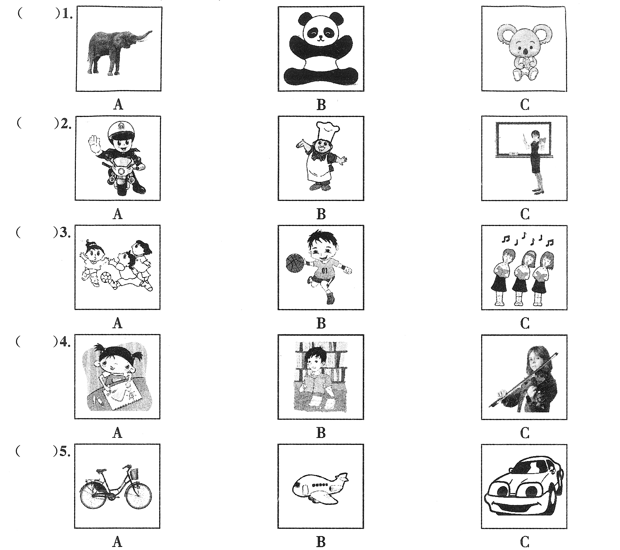

第二节 对话理解 听下面的对话，从题中所给的A、B、C三个选项中选出最佳答案。听每段对话前，你将有时间阅读各个小题，每小题5秒钟；听完后，各小题将给出5秒钟的作答时间。（共10小题，计10分）
听下面的对话，回答第6小题。
( ) 6. When did Henry arrive in London?
A. Yesterday. B. Today. C. Two days ago.
听下面的对话，回答第7小题。
( ) 7. What does Jane do every morning?
A. Plays basketball. B. Reads. C. Runs.
听下面的对话，回答第8小题。
( ) 8. When does the woman often drink milk?
A. At breakfast. B. At lunch. C. At supper.
听下面的对话，回答第9小题。
( ) 9. Who is Jane spending time with?
A. Her friends. B. Her family. C. Her classmates.
听下面的对话，回答第10小题。
( ) 10. Why does the girl think a healthy lifestyle is important to us?
- Because she thinks it helps us sleep well.
- Because she thinks it helps us get good grades.
- Because she thinks it helps us stay happy.
听下面的对话，回答第11～12小题。
( ) 11. What’s the matter with the woman?
- She is too weak to do any work.
- She can’t sleep very well at night.
- She has a headache.
( ) 12. When did she start to have the trouble?
A. Last night. B. Last week. C. Last month.
听下面的对话，回答第13～15小题。
( ) 13. What is the woman?
A. A teacher. B. A reporter. C. A policewoman.
( ) 14. How often does the man exercise?
A. Four times a week. B. Every day. C. Four times a day.
( ) 15. Does the man often go shopping?
A. No, never. B. Yes, sometimes. C. Yes, very often.
第三节 笔录要点 根据你所听到的内容，填写下面的表格，每空不超过3个单词。（共5小题，每小题2分，计10分）
Name | Mr. Smith
Job | 16.
Where is he going? | 17.
Plans for vacation | go 18. in the morning
Plans for vacation | go 19. and boating in the afternoon.
Plans for vacation | Watch TV and 20. a lot in the evening
Ⅱ. 知识运用（共20分）
- 选择填空（共10小题，计10分）
( ) 21. --- Whose are the two bikes?
--- They belong to _______.
A. she and me. B. her and me C. she and I
( ) 22. --- Wish you a pleasant journey, Alex.
--- _______.
A. Thank you B. I’d love to C. I’m afraid not
( ) 23. Eating more ______ like carrots, tomatoes and broccoli is good for you.
A. meat B. fruits C. vegetables
( ) 24. --- Hi, Tom. How are the things ______?
--- Not bad.
A. happening B. coming C. going
( ) 25. We often go swimming in the lake ______ July.
A. to B. on C. in
( ) 26. Lucy and Lily ______ sisters. They study at the same school.
A. be B. are C. is
( ) 27. When someone is ill, he _____ she should try to smile at life.
A. and B. but C. or
( ) 28. People in America eat much _____.
A. coffee B. onions C. beef
( ) 29. --- Are you in Grade One, too?
--- _______.
A. Yes, I am. B. No, I am. C. Yes, I’m.
( ) 30. --- ______?
--- It’s a cake.
A. Is this a cake? B. Is it a cake? C. What’s that?
B). 完形填空（共10小题，计10分）
How is it going? I hope that grandpa is_31_ now. I was sorry to hear that he had a _32_
last week. I hope you are in good health.
Things are fine now. I finished my end-of-year exams last week and got my _33_ card today. I always get _34_ when I see the envelope from the school in the mail, but _35_ I did OK this time. I had a really hard _36_ with science this semester, and I wasn’t surprised to find that my worst report was from my science teacher. She said I was lazy, which isn’t _37_ . It’s just that I find science really difficult. _38_ disappointing result was in history. My history teacher said I could do better. The good _39_ is that my math teacher said I was hard-working. And my Spanish teacher said my listening was good.
Well, that’s about all the news I have for now. Dad and Mum _40_ their love,.
Love,
Alan
( ) 31. A. well B. rich C. busy
( ) 32 . A. rest. B. dream C. cold
( ) 33. A. report B. ID C. phone
( ) 34. A. excited B. sad C. nervous
( ) 35. A. carefully B. luckily C. suddenly
( ) 36. A. business B. question C. time
( ) 37. A. important B. true C. boring
( ) 38. A. Each B. Some C. Another
( ) 39. A. meaning B. notice C. news
( ) 40. A. have B. send C. provide

Ⅲ.阅读理解：（共20小题，每小题2分，计40分）
A) 阅读下列短文，在A、B、C三个选项中选出正确答案。（共15小题，每小题2分，计30分）奥思特
A
Wanted
Taxi drivers  (Hope Taxi Company) | - 4 full-time taxi drivers  - Over 5 years’ experience  - Good knowledge of the city  - Under 45 years old
Tour guides (Friendship Tour Company) | - 2 years’ experience  - Good English  - Good at talking  - 20-30 years old
Postmen  (Happiness Post Company) | - No experience necessary  - Can choose working hours  - Under 35 years old  - Must be hard-working  - Have a driver’s license
( ) 41. How many taxi drivers does Hope Taxi Company need?
A. 2. B. 4. C. 5.
( ) 42. If you want to be a taxi driver, you should _______.
- know the city very well.
- be over 45 years old
- have two years’ experience
( ) 43. The tour guide wanted should _____.
- be under 35 years old
- speak English well
- have a driver’s license
( ) 44. Happiness Post Office needs _____.
A. full-time drivers B. tour guides C. hard-working postmen
( ) 45. To which company is experience not necessary?
A. Hope Taxi Company B. Friendship Tour Company
C. Happiness Post Company

B
In Xinjiang, most people knew the stories of Avantis(阿凡提), Avantis was a very clever man. People liked him because he not only spoke for the poor but also was always ready to help them.
One day Avantis saw two men arguing with each other. A lot of people stood around them. One of the two men was the owner of the eating house in the town and the other was a young man. The young man just passed by the eating house. The owner of the eating house told the young man to pay him money. The young man explained that he hadn’t taken anything from the eating house. But the owner said that the young man had taken the smell of the nice food from the eating house, and he must pay for it. So Avantis went up to the owner and said,“I’ll pay you the money.”Avantis took out some coins from his pocket and put them into his own bag. He shook his bag, and people heard the sound of coins. Then Avantis said to the owner, “I have paid you the money.”
46. People liked Avantis because _________.
A. he was clever and disliked helping the poor
B. he was rich and liked helping the poor
C. he was clever and liked to help the poor
47. One day Avantis saw two men ________.
A. arguing about the eating house
B. arguing about the payment
C. laughing at the people around them
48. The owner of the eating house told the young man _______.
A. to pay the enough money for his food
B. to pay the money for broken bowls
C. to pay for the smell of the food
49. Avantis wanted to help the young man, so _______.
A. he helped the young man out of the trouble
B. he would pay the money instead of the young man
C. he asked the young man to make friends with the owner
50. Avantis paid the owner of the eating house _______.
A. enough money B. some coins C. the sound of the coins

C
Do you like chocolate? Maybe most people do. A box of it can be a great gift. Buy one for a friend and give it a surprise. See how happy that person gets.
Say you just got a box of chocolate. Which piece do you pick first? A man has studied people’s choices. He says they tell something about the person. Did you choose a round piece? You are a person who likes to party. Did you choose an oval(椭圆形的) shape? You are a person who likes to make things. Picking a square shape shows something else. The person is honest and truthful. You can depend on him or her.
What kind of chocolate do you pick? Maybe you like milk chocolate. This shows you have warm feeling about the past. Dark chocolate means something else. A person who chooses it looks toward the future. What about white chocolate? Would you choose it? If so, you may find it hard to make up your mind. Some people like chocolate with nuts(果仁). These are people who like to help others.
Do you believe theses ideas? Can candy tell all these things? It doesn’t really matter. There is one sure thing about eaters of chocolate. They eat it because they like it.
( ) 51. This passage mainly tell us ______.
- why people like chocolate
- almost everyone like chocolate
- different choices may show different characters
( ) 52. Picking a round shape of chocolate shows that a person _____.
- like singing, dancing and drinking
- likes to do something for others
- is good at making things
\( ) 53. If you enjoy eating milk chocolate, you may _____.
- look forward to the future
- like to think of the past
- enjoy parties and fun
( ) 54. From the passage we can say that a helpful man may choose chocolate ____.
A. in oval shape B. in square shape C. with nuts
( ) 55. The last paragraph suggests that the writer _____.
- believes all the information about chocolate
- does not believe the information about candy
- doesn’t think it important whether you believe the ideas or not

B) 回答问题（共5小题，每小题2分，计10分）
阅读下列短文，然后回答后面的问题。奥思特
TV news programs report the weather. Radio stations tell us the weather, too. Newspapers show us weather forecasts(预报) on maps.
Why do people want to know about the weather? People want to make plans. Some people want to have a good time with friends. Other people want safety while doing their jobs.
Airport managers need to know about the weather. In bad weather, their planes cannot fly. Farmers need to know about the weather. In bad weather, they must protect their crops. Fishermen need to know about the weather. In bad weather, they cannot go out to fish.
Computers help us to know about the weather. They get new weather information quickly. They can use this to predict(预测) how the weather might change. Unfortunately, we can still only guess the weather. We all hope that weather will be easier to predict in the future.
56. Where can you get information about the weather?
________________________________________.
57. Why do people need weather forecasts?
________________________________________.
58. Why do farmers need to know about the weather?
________________________________________.
59. Do fishermen need weather forecasts? Why or why not?
________________________________________.
60. What is the passage mainly about?
________________________________________.

Ⅳ. 写作技能(共35分)
  - 摘录信息（共5小题，每小题2分，计10分）
下面的文章，然后根据文章完成后面的表格，每空不超过3个单词。
Recently I was walking in town when I saw a group of school students in uniform. I was shocked to see that the girls’ skirts were very short and they were wearing a lot of make-up. The boys looked untidy. Their shirts were dirty and some of them even had their shirt fronts open. I noticed that some of their students had pierced ears and nose, which I don’t think should be allowed at school.
And the other day, I was riding on the subway when I saw some boys from a local school. I know they were from this school because they were wearing the same uniform as my children. Instead of sitting quietly, these boys were making a lot of noises, chewing gum in an ugly manner, and using bad language. All the other passengers were looking at them and wondering how it was possible for these boys not to have any self-respect(自尊). They were also giving their school a very bad image(形象)，which is shameful(羞耻的).
I am a mother of two teenagers at this school and I’m worried that my children also behave like this and I do not know about it. Do school students know what is allowed and what is not allowed when they are wearing their school uniform? I think the school should be stricter with the students. And I think all students should be taught how to be polite.
Be supposed to | Not be 61. to
Dress up as a school student | Wear very short skirt  62. one’s ears or noses
Keep uniform clean and tidy | make uniform 63.
Behave politely | 64. when talking
Obey the public rules | make 65. in public

B）完成句子（共5小题，每小题2分，计10分）
读下面对话，然后根据上下文完成句子。
A: Good news! Our class has won the first place in the basketball game.
B: Really? 66 _____________?
A: Mr. Zhang, our P.E. teacher told me about it just now. And he said that we would have a party to celebrate it.
B: Sounds great! 67 ____________?
A: This Friday evening.
B: 68 _______________?
A: I will sing an English song “My Heart Will Go On”.
69 _______________?
B: Of course. I have heard it many times.
A: 70 ________________?
B: It sounds beautiful. I like it very much.

C)作文(共15分)
你在和Eric的交流中了解到中美两国课堂有各自不同的一些特点，请你根据下表简要描述这些特点，并就此谈谈自己的想法。
 | 中国课堂 | 美国课堂
特点 | - 不称呼老师的姓名  - 仔细听讲、做笔记  - 举手发言 | - 学生面对面就座  - 比较放松，可以喝饮料  - 自由谈论
你的想法 | … …
要求：(1)文章必须包括表中所有信息，可适当增加细节但不要逐条翻译；
(2)想法必须在2个句子以上；
(3)文章开头已给出（不计入总词数），你只需接着写；
(4) 词数在70左右。
There are some differences between a Chinese class and an American class. Let’s have a look. In China,……

英语参考答案

Ⅰ 1 --15 CAACA CCAAB ACBAA
16. a doctor 17. Japan 18. fishing 19. swimming 20. sleep

Ⅱ 21--30 BACCC BCCAC 31—40 ACACB CBCCB

Ⅲ 41—55 BABCC CBCAC CABCC
56. TV\Radio\Computer.
57. People want to make plans.
58. In bad weather, they must protect their crops.
59. Yes, they do. Because in bad weather they can’t go out
to fish.
60. Weather forecast\prediction.

Ⅳ A) 61. allowed 62. get\have pierced
63. dirty and untidy 64. use bad language
65. lots of noises
B) 66. How did you know about it\Who told you about it
67. When shall we celebrate it
68. What will you do
69. Have you ever heard it before
70. How do you like it

C) one possible version
There are some differences between a Chinese class and an American class. Let’s have a look. In China, students call their teachers with “Mr” or “Miss”. In class, they always listen to the teachers and take notes carefully. If they want to show their own ideas, they have to put up their hands first. However, in America, students sit around the desks, face to face. They have pretty relaxed rules. They can even drink coffee or juice during classes. Also, they can speak out in class freely. Different countries have different cultures. But I think Chinese class is better. We should be strict in our study.

