2015年上学期九年级调研考试
英语试题
时量：90分钟 总分：120分
第一部分 听力技能 (共两节，计25分)
第一节 听力选择 ( 15小题，计15分)
根据你听到的对话，选择正确的答案回答问题。
听下面5段对话，每听完一段对话后，做1个小题。
1. How many books can a student borrow at most?
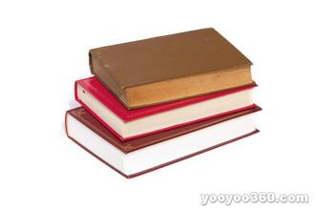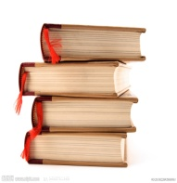
A. B. C.
2. How is Mrs. Smith going to spend her holiday?
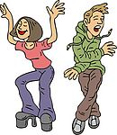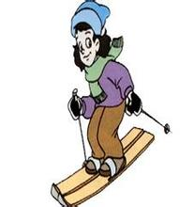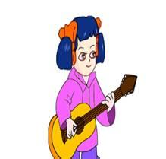
A. B. C.
3.Where are they going ?
A. To a city. B. To a lake. C. To a shopping mall.
4. What are the boys doing?
A. Swimming. B. Reading. C. Planting some trees.
5. How is the river now?
A. Dirty. B. Deep. C. Clean.
听第六段对话，做第6—7小题。
6. What are they talking about?
A. A folk story. B. A short play. C. A new movie.
7. How do they like of Pang Meng?
A. Bad. B. Brave. C. Wise.
听第七段对话，做第8—9小题。
8. Who found the schoolbag?
A. Peter B. Tina C. Judy
9. Why did they have a big party for Miss Zhou?
A. Because she was sad. B. Because it’s her birthday.
C. Because she was moved.
听第八段对话，做第10—12小题。
10. What season is it now?
A. Spring B. Autumn. C. Winter.
11. How many times has the woman seen snow before?
A. Twice. B. Once. C. Never.
12. Where does the woman come from?
A. The north. B. The south. C. The east.
听第九段对话，做第13—15小题。
13. What is the man’s problem?
A. He can not afford an iPad. B. He can’t decide what to buy.
C. He doesn’t know where to buy a laptop.
14. Why is the man going to China?
A. To find a job. B. To visit a friend. C. To spend a holiday.
15. What will the man mainly use the laptop for?
A. To play games. B. To read books. C. To do some writing.
第二节 笔录要点 ( 5小题，计10分)
根据你所听到的内容，填写下面的表格，每空不超过3个单词。
A school trip to Yunnan
Time | (16)_________.
Spots | Kunming, known as (17)_________.  Dali, which is famous for its (18)_________.  Lijiang, where Mount Yulong lies.
Advice | Bring(19) _________ and some thick clothes .  Don’t take too much cash.  You can use your (20)_________.

第二部分 知识运用（共两节 计25分）
第一节 语法填空 ( 15小题，计15分)
从A、B、C三个选项中选择正确的答案填空。
21. —Do you often play _______ soccer with your friends?
—No, I don’t like sports. I often play______ piano in my free time.
A. a, the B. the, / C. /, the
22. The little boy is only 5 years old. He is ______ young ______ go to school.
A. too…to… B. so…that… C. not…enough…
23. I can’t find _____ bike. Can I use _____?
A. my, your B. my, yours C. mine, yours
24. My sister is a reporter. She often works hard ______ some interesting news for people.
A. getting B. gets C. to get
25. —May I speak to Mr Wang?
—Sorry. He______ a speech now. Please call later.
A. gives B. gave C. is giving
26. _____ is reported that the No. 2 Underground in Changsha is now in use.
A. It B. That C. This
27. In our school, the first class begins _________eight o’clock ________the morning.
A. at, on B. at , in C. in, on
28. — _______ is it from your home to the bus stop?
— It’s about 2 kilometers.
A. How long B. How far C. How many
29. That kind of mobile phones ________ for surfing internet and watching TV.
A. uses B. is used C. are used
30. Look at this amazing photo! ________ special it is!
A. How B. What C. What a
31. —Can I swim here?
—I’m sorry. It’s dangerous. Please look at the sign “______”.
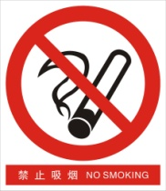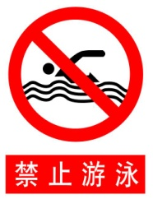
A B C
32. It’s too noisy in the room. Why don’t you _____ the music?
A. turn up B. turn on C. turn down
33. My father often talks about the village_________ he lived with his parents thirty years ago.
A. when B. which C. where
34. They are twin brothers from America. _______ one is good at playing tennis.
A. The taller B. The tallest C. The tall
35. —Could you tell us__________? I miss my parents.
—In three weeks.
A. how often are we going back home
B. how long we are going back home
C. how soon we are going back home
第二节 词语填空 ( 10小题，计10分)
通读下面的短文, 掌握其大意, 然后从各题所给的A、B、C三个选项中选出一
个最佳答案。
One windy afternoon, Tommy was on his way home from school. When he was passing by his
neighbor, Mr. Adamson's house, he found thick 36 coming from the window of the house. He was 37 . He thought the house must be on fire and it might be burnt down. He didn't know
whether Mr. Adamson was in the house, 38 he knew he must put out the fire at once. So he ran to his own house, rushed into the bathroom and 39 a big barrel（桶） with water. He was in
such a hurry that he forgot to 40 the water before he ran back to Mr. Adamson's house.
When he reached the window where the smoke was still coming out, he threw the water 41
the house by the window without looking for where the smoke was. The smoke stopped
immediately. But at the same time, there was an angry cry from inside the house. 42 was Mr.
Adamson. He was standing by the window with so big a pipe （烟斗） in his hand looking
at Tommy 43 . Tommy then understood that it must be the pipe.
He stood there, and could not 44 a word. Tommy was very sorry for it. He helped Mr.
Adamson clean the floor. However, worst was yet to come. When he went home later, he found his
own 45 was flooded （淹没）.
36. A. water B. smoke C. rain
37. A. afraid B. happy C. excited
38. A. since B. or C. but
39. A. filled B. covered C. left
40. A. turn up B. turn on C. turn off
41. A. out B. into C. away
42. A. This B. It C. One
43. A. angrily B. lazily C. happily
44. A. tell B. write C. say
45. A. school B. window C. house
第三部分 阅读技能（共三节，计40分）
第一节 阅读选择 ( 10小题，计20分)
阅读下面的短文，从每题所给的A、B、C三个选项中，选出最佳选项回答问
题或完成句子。
A
As time goes on, people have come to realize the importance of protecting the environment. But they can’t deal with everything by themselves. Take small steps, and you can make a difference.
● Think Green. Think about the environment as you live your life. If you turn off lights and TV when leaving the room, you’ll save energy. If you take shorter showers, you will save water.
● Shop Green. Shopping is fun, but buying things you don’t need is wasteful and even bad for the earth. Before you buy something, ask yourself how much you will use it, and whenever possible, buy things locally made instead of those shipped from far away.
● Dress Green. What really matters is not the color. It’s how the clothes were made. So look for products made from environmentally friendly(环保的) materials.
● Study Green. What’s better than learning about the environment? Save it while you learn. It can be as simple as suing both sides of a piece of paper before you recycle it.
46. What does the writer want us to do?
A. Know some facts. B. Deal with everything at once.
C. Protect the environment.
47. What does the phrase “ make a difference” mean in Chinese?
A. 制造区别 B.起重要作用 C. 造成麻烦
48. How many steps can we take according to the text?
A. Three. B. Four. C. Five.
49. Which of the following is the writer’s idea?
A. Take a shower as long as possible.
B. Wear clothes whose color is green.
C. Buy things that are locally make.
50. The text is most probably written for _____.
A. men B. women C. all people

阅读下面的图表，做51-52小题。
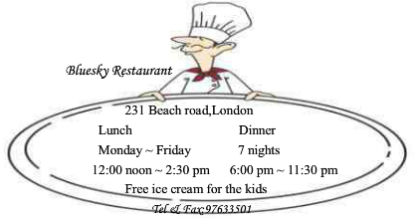

51. You can have lunch at Bluesky Restaurant at _______ on weekdays.
A. 11:30 B. 2:00pm C. 6:30pm
52. What information you can’t get from the picture?
A. Address B. Fax C. Email
阅读下面的图表，做53-55小题。
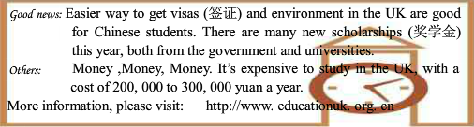
53.The picture is probably from _______.
A. a magazine B. newspaper C. a tour guide book
54.If you want to study in the UK, how can you get more information?
A. Call 976-3501.
B. Visit http://www.educationuk.org.cn
C. From the government and universities.
55.Which of the following is NOT true?
A. Getting UK visas is easier.
B. It's not expensive to study in the UK.
C. Students can get scholarships from the government and universities as well.

第二节 摘录要点 ( 5小题， 计10分)
阅读下面的材料，然后在表格中完成内容摘要，每空不超过三个单词。
These days when you go on vacation, you spend most of your money just getting there. Travel
is expensive, but don't stay home only because you are short of money! Here is some advice:
* Travel during off-season if possible. Flights and hotels are very cheaper when tourism is low.
* Choose a hotel that's a little farther from popular attractions. If you're staying several days,
check out prices on vacation homes — it can end up being cheaper than a hotel.
* Take public traffic, such as buses or subway, instead of taking a taxi.
* Plan your meals, and eat like locals. Don't waste money at expensive hotel restaurants or
fast-food chains. Depending on where you stay, it may be cheaper to make food on your own.
* Check online for special discount （折扣） — if you're a student, the old or the parents
traveling with children, you could get discounts! A little research could save you a lot of money.
Whether you're backpacking alone or going on a family vacation, your trip doesn't have to break
the bank. The key is to plan ahead and write down what you spend. Then put the money you save
toward your next trip!
(56) ________ on how to save money about travelling
Time | Travel (57) ________ if possible.
Hotels | ● Choose a hotel that's a little farther from popular attractions.  ● If you're staying several days, check out prices (58) _______.
(59) ________ | ●Plan your meals, and eat like locals.  ●It may be cheaper to make food on your own.
Means of Transportation | Take (60) ________ , such as buses or subway, instead  of taking a taxi.
Special discount | Check online for special discount.

第三节 回答问题 ( 5小题计10分)
阅读下面的材料，然后根据材料内容回答问题。
iPads for Apes
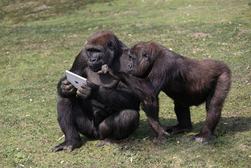Humans love iPads. And it seems animals do, too! Zookeepers at Miami’s Jungle Island Zoo are teaching apes how to use the popular Apple gadget(小装置) so that the apes can communicate with their keepers.
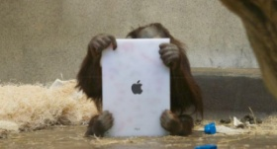“Apes have all the intelligence they need to communicate with us,” said zookeeper Linda. “But what they don’t have is developed vocal chords(声带) and voice boxes. An iPad gives them a voice.” The apes use the iPads to tell their keepers what they want for lunch. The keeper holds the tablets(牌) to the cage and the apes point to the pictures of the vegetables they feel like eating. “Some of them like carrots more than they like beets(甜菜根). And don’t we all want to have that choice?” said Linda.
Meanwhile, the zookeepers are also making new plans with the purpose of helping apes at different zoos communicate with each other through iPads.
61. Where are the zookeepers teaching the apes to use iPads?
__________________________________________________
62. What don’t the apes have according to the text?
__________________________________________________
63. How do the apes use the iPads to tell their keepers what they want for lunch?
__________________________________________________
64. Why are the zookeepers making new plans at the same time?
__________________________________________________
65. What do you think of the iPads for the apes?
__________________________________________________
第四部分 写作技能（共三节，计30分）
第一节 翻译语篇 （5小题，计10分）
阅读下面的短文，然后将划线部分的句子译成汉语或英语。
Sandy was the last to arrive at the museum. She was so tired that she had to find a chair to sit on. Once she sat down, 66. she noticed a nice painting on the wall. She stared at it for a long time – so long, that she fell asleep.
Suddenly, 67. 她听到有人在唱歌. She went to see who it was but there was nobody in sight. She was confused. Then she turned to a painting on the wall. It was the Mona Lisa. She was interested in the painting. To her surprise, Mona Lisa was singing loudly.
She wandered to the other side of the hall and came across another painting on the wall. 68. There was a woman in a beautiful dress walking in the painting. The woman smiled at Sandy and reached out her hand towards her. Sandy was sure she could smell the flowers she was wearing.
69.接着那个女士给了她一个大大的红苹果。Sandy hesitated about whether she should eat it. She felt very hungry. 70. “It looks delicious,” She thought. Sandy bit into the apple. It tasted sweet.
第二节 完成对话 （5小题，计10分）
根据上下文和你的实际情况把下面的对话补充完整。
A: Hi, Mike. How is it going?
B: Pretty good. Summer vacation is coming. We can enjoy ourselves.
A: Yes.71._________________ ?
B: I’m going to Harbin.
A: 72._____________________?
B: Because I think it’s cool there in summer and my brother works there.
A:73._____________________ ?
B: I’m going to stay there for a week.
A: How are you going there?
B:I’ll go there by air. It is the fastest way because it only takes about 4 hours.
B: 74._________________?
A: I’m going with my parents. How about you?
B: I’m going to Beijing with my sister.
A: Enjoy yourself!
B: 75._________________. The same to you!

第三节 情景作文（10分）
假如你是Mary，你想申请去美国作交换生，参加为期一年的学习。请你用英语写一篇自我推荐信给申请学校，写出自己最精彩的一面，内容可以包括自己的特长、成就、梦想以及学校的生活等等，可适当发挥。
注意： （1）80字左右；
（2）文中不能出现可能透露考生真实身份的任何信息。
Dear Sir,
____________________________________________________________________________________________
____________________________________________________________________________________________
____________________________________________________________________________________________
____________________________________________________________________________________________
____________________________________________________________________________________________
____________________________________________________________________________________________
Yours,
Mary

